Political Jurisdiction in Post-Autocratic Courts:
A Topic Model Approach

Fiona Shen-Bayh
fishenbayh@berkeley.edu
Ph.D. Candidate
UC Berkeley

April 2018

< Draft prepared for VIM 2018 >

Abstract: To what extent have autocratic legacies persisted in post-autocratic courts? Existing research on judicial politics has focused on the democratic dimensions of judicial behavior, often rooted in the concept of judicial independence. However, existing concepts and metrics can obscure variation in the exercise of judicial authority, especially in countries with long histories of autocratic rule. This paper introduces a new approach to the study of judicial power based on jurisdiction, or the scope of legal decision-making. Whatever jurisdiction a court is allowed to exercise provides insight into the underlying relationship between political leaders and judges, as well as the types of cases that are deemed worthy of adjudication. I develop a novel measure of this concept using a computational topic modelling approach, drawing on news media compiled from seven African countries that discuss judicial themes. Using a series of static and dynamic topic models, I analyze the news corpus consisting of 18,944 articles. My findings show that contemporary patterns of jurisdiction in African courts reflect patterns of judicial power that were established decades before under autocratic rule.

It has been nearly three decades since the end of one-party dictatorship across much of the African continent. While the 1990s ushered in a new era of political and economic liberalization, creating unprecedented opportunities for institutional reform, the long-term impact of these initial openings has remained debatable. In fact, recent scholarship has highlighted global trends of democratic backsliding (Bermeo 2016), drawing attention to the endurance of autocratic legacies on post-autocratic development (Riedl 2014; Albertus and Menaldo 2012). The evidence suggests that autocratic institutions are more impervious to reform than originally imagined (Carothers 2002; 2006).

In light of these trends, to what extent have autocratic legacies persisted in African courts? Existing research on judicial performance has focused on democratic dimensions, often rooted in the concept of judicial independence (Moustafa 2015). The central idea of independence is simple: judges should be autonomous agents of the law who make decisions without political interference (Linzer and Staton 2015). This is considered a central pillar of the rule of law, which in turn is a critical component of a functioning democracy (Carothers 2002). However, not all courts are designed to support a democratic rule of law, and a variety of autocratic regimes have instead used courts to both consolidate and maintain autocratic power (Ginsburg and Moustafa 2008). Considering that courts are often designed for explicitly partisan objectives, independence may not always be the best criterion by which judicial performance is appraised.

I propose an alternative conception of judicial power: jurisdiction. Jurisdiction describes the scope of judicial authority, or the legal domain over which a court is allowed to make decisions. Consider how in the one-party dictatorships of sub-Saharan Africa, courts were granted jurisdiction over political conflicts only when judges could be trusted to deliver rulings in favor of the incumbent. Jurisdiction could shift over time, since judges who ruled against the regime might have their power eroded in future cases. Taken in this context, whatever jurisdiction a court is allowed to exercise provides insight into the underlying relationship between political leaders and judges, as well as the types of cases that are deemed worthy of adjudication.
Jurisdiction is a tangible concept that can be observed through a variety of indicators, although conventional metrics have certain caveats. While legislation shows how political leaders formally define the scope of judicial authority, the law itself does not indicate whether such authority is ultimately invoked or challenged. In addition, court records can reveal what types of cases are actually brought before a judge, but they only contain the proceedings of a given case. As such, court records do not provide a complete picture of the dynamic relationship between politicians and judges, especially interactions that may occur beyond the courtroom.

To develop a more comprehensive measure of jurisdiction across countries and over time, I turn to news media. African courts have received extensive coverage in the local press since the early 1990s, ranging from stories of judicial reform to trial proceedings. Unlike formal legislation or court records, news media covers events before, during, and after judicial events. It also captures broader perceptions of judicial performance, including commentary on support for or backlash against decisions of the court. In these ways, news media, especially locally-based reports, can provide real-time coverage of judicial politics both in and out of the courtroom, contributing to a more holistic view of the courts in their environment.
Scholars have long used news media to collect event data and build aggregate indices of various political concepts. However, the vast majority of this work is performed by human coders who are often required to sift through thousands of individual articles for relevant information. I propose a more efficient alternative using web-based methods of data collection and natural language processing, which allows for the systematic retrieval and analysis of news media on a much larger scale. I used web crawling methods to build a corpus of 18,944 news articles dating from 1996-2017 from AllAfrica, an online repository of local African news media. The media corpus is then analyzed using static and dynamic topic models, both of which are computational methods that infer latent topics from unstructured texts. The results suggest that contemporary African courts exercise a diverse array of jurisdictions, ranging from election petitions to the protection of human rights. However, when taken in broader historical context, contemporary trends reflect important autocratic legacies: courts which exercised more limited jurisdictions during the autocratic era have more volatile jurisdictions today. Furthermore, these outcomes suggest that the scope of jurisdiction can reflect the underlying relationship between judges and leaders, which may be adversarial, supportive, or mixed. My findings suggest that when relationships between judges and leaders become institutionalized, they are difficult to transform, even after transitions to more democratic rule.

In what follows, I provide an overview of the democratic concepts and metrics that have dominated existing research on judicial politics. Next, I provide a novel measure of jurisdiction that relies on news media and computational text analysis. My findings show that this approach provides a measure of judicial power that is both efficient and generalizable to both democratic and autocratic regimes. Finally, I evaluate the endurance of autocratic legacies by turning to Malawi and Kenya, countries with share common autocratic legacies but drastically different trajectories of jurisdictional development.

- The study of judicial power in developing countries
Over the past three decades, research on comparative courts has centered around issues of judicial independence. Whether judges are considered autonomous agents of the law or mere pawns of power, the notion of independence has become one of the most widely used criteria for evaluating judicial performance (Rios-Figueroa and Staton 2014; Linzer and Staton 2015). Judicial independence is typically broken down into a variety of sub-concepts. Two commonly invoked categories are de jure and de facto, where de jure independence is rule-based, and de facto independence is performance-based. In either instance, the central idea is that judges have the power to constrain arbitrary authority.

The primacy of judicial independence in the literature on legal development reflects geopolitical trends that began to take shape in the late 1980s and early 1990s. This was an unprecedented period of political liberalization across the developing world, a phenomenon that largely became known as the “Third Wave” of democracy (Huntington 1991). The seeming global breakdown of autocratic regimes was welcomed by many western democracies, most notably countries within the U.S. foreign policy community (Carothers 2002). An array of governmental, quasi-governmental, and nongovernmental organizations thus began to actively promote the democracy transition paradigm, a sweeping program of development that was highly invested in rule of law reforms. These reforms were rooted in the idea that a functioning legal system, including an independent judiciary, was a panacea for political illiberalism and economic underdevelopment (Carothers 1998). Both scholars and democracy promoters began collecting data from developing countries, especially observable indicators of institutional reform that could be tracked across countries and over time. As such, a variety of rule-of-law measures sprang into existence, including several metrics related to judicial independence.

Research on judicial reform in developing countries was profoundly influenced by these broader geopolitical forces, where the vast majority of legal development indicators were conflated with democracy. However, failures of the Third Wave have led to a systematic reevaluation of legal institutions in developing contexts (Carothers 2002). In many cases, criteria for reform has become more stringent over time, in part to account for democratic backsliding. Fariss (2014) illustrates these dynamics using 35 years of human rights data on developing countries. The vast majority of this data has come from two monitoring agencies: Amnesty International and the U.S. Department of State. Fariss shows that both agencies have developed more rigorous methods of evaluation since they began collecting data, such that developing countries are being held to higher standards of accountability than they were several decades ago. While improvements in identification and measurement are to be welcomed, changing standards over time can lead to inconsistent evaluations and inappropriate generalizations. Indeed, most cross-national, time-series data must be corrected using a variety of latent variable models in order to generate comparable findings (Fariss 2014; Linzer and Staton 2015).

However, statistical corrections cannot always capture shifts in on-the-ground behavior. This is especially true in contexts where governments have found ways to obfuscate practices that would otherwise be considered abusive and hence worthy of sanction. The anti-corruption movement in sub-Saharan Africa is a prime example. Since the early 1990s, a variety of institutions related to combatting corruption have proliferated in African countries. While these institutions are ostensibly targeted against public malfeasance, they are frequently used to eliminate political rivals. In other cases, governments have effectively sidelined opposition actors by accusing them of criminal activity. Framing political rivals as subversive criminals is a longstanding practice in many autocratic regimes, but the fact that such practices continued to be used by post-transition governments suggests more attention should be directed towards the criminalization of democratic behavior.

In many cases, post-transition regimes have merely placed one form of repression into a more acceptable container, where political persecution is rebranded as legitimate prosecution. However, if repressive practices have merely been rebranded, how can we develop a consistent means of evaluating judicial performance over time? What is an appropriate way of comparing institutions operating under fundamentally different geopolitical contexts?

Recent efforts to move beyond the democracy paradigm have led to innovative scholarship on courts in autocratic regimes (Moustafa 2007; Moustafa and Ginsburg 2008; Helmke 2002 and 2005; Pereira 2005; Magaloni 2008; Solomon 1996). This work shows that even limited judicial independence can be leveraged by autocrats to address key pathologies of authoritarian rule (Moustafa 2007). While this research has provided valuable insight into the form and function of judicial power in nondemocratic settings, it has also led to a dichotomy between the literatures on democratic and autocratic courts (Moustafa 2015). This is the danger of conflating legal institutions with regime-type, where courts are considered independent if they abide by democratic principles, and dependent if they do not constrain arbitrary rule (Kapiszewski and Taylor 2008). The reality is that seemingly democratic or autocratic institutions are often neither: just because a country holds elections does not make them free and fair, and a government which lacks a formal constitution does not necessarily rule without restraint. While scholars have long recognized the existence of authoritarian or democratic enclaves in so-called hybrid regimes (Levitsky and Way 2002; Schedler 2010), these insights have not been examined as extensively in the study of judicial politics.

Although recent studies on autocratic courts have highlighted alternative paths of judicial development, this research remains segmented from other work on courts in democratic regimes. Categorizing courts by regime-type has overlooked gradations of judicial behavior that are neither fully democratic nor authoritarian, which has stymied our ability to generalize the performance of law and courts across diverse geopolitical contexts. The result has been a disconnect between our understanding of why courts support rule of law in some contexts, but reinforce dictatorship in others.

- A new concept of judicial power: jurisdiction
This section proposes an alternative conception of judicial authority that is not necessarily rooted in the democratic experience. I focus on jurisdiction, which describes the range of legal issue-areas over which a court exercises its power (Jaffe 1964; Cover 1985). This concept is fundamental towards describing the exercise of judicial authority, in both democratic and autocratic regimes alike. As U.S. Supreme Court Justice Samuel P. Chase observed in the late 19th century, “without jurisdiction the court cannot proceed at all in any cause. Jurisdiction is power to declare the law, and when it ceases to exist, the only function remaining to the court is that of announcing the fact and dismissing the cause.”

However, jurisdiction is about more than the legal-areas of judicial power; it also identifies whether judges are major political decision-makers or relatively marginal actors. This is distinct from conventional notions of independence, which focus on how authority is exercised, but not where that authority lies. Jurisdiction directs attention to the latter, since this essentially determines whether judges are even allowed to hear politically significant cases in the first instance.

Consider Singapore, where the Supreme Constitutional Court is considered both de jure and de facto independent by many economic indicators, yet lacks substantive authority over political rights (Silverstein 2008; Jothie Rahaj 2012). Similarly in Hong Kong and China, the courts are granted relative autonomy in commercial cases that concern investors rights, but otherwise lack meaningful authority to adjudicate the violation of human rights (Lubman 1999; Peerenboom 2002; Wang 2014). The key takeaway is that evaluating courts by independence alone can be highly misleading, since independence is often carefully controlled by limiting or expanding jurisdiction over discrete legal domains. Regimes can thus cultivate limited judicial independence without making themselves fully accountable to the law (Moustafa 2015).

The scope of jurisdiction can also reveal broader governing priorities of political leaders. In the examples highlighted above, governments wanted to liberalize markets without liberalizing power, and hence granted judicial autonomy over economic, not political, rights (Wang 2014). In other examples, governments extend the constitutional jurisdiction of the courts in order to legitimize unconstitutional behavior. This is especially common among leaders that have come to power via coup and seek legal validation of their illegal seizure of power (Mahmud 1994; Del Carmen 1973; Tate and Haynie 1993). Such tactics are not limited to autocratic regimes: democracies will also extend the authority of courts for various political objectives. For example, new democracies may grant judicial review over electoral or administrative rules as a means to defuse conflicts within the legislature (Finkel 2003). Regardless of regime type, jurisdiction can thus reflect the specific priorities of a given government.

The discussion so far suggests that judges are relatively passive actors in their political environment. This is true to a certain extent, since judges are largely considered reactive rather than proactive agents of the law (Gloppen 2003). However, this does not mean that judges lack all agency over the determination of their own jurisdiction. Jurisdiction can actually expand or contract based on the underlying relationship between judges and their political leaders (Hart 1953). One of the most famous examples is the U.S. Supreme Court case Marbury vs. Madison, which radically expanded the powers of the Court to review the constitutional actions of government (Amar 1989). According to Knight and Esptein (1996), this power was established as a byproduct of strategic conflict between the President and the Chief Justice, both of whom sought the supremacy of their respective offices. While the contest for supremacy set the precedent of judicial review in America, provoking conflict with presidents can backfire for judges in other contexts. In post-independence African countries, controversial rulings often undermined judicial authority in the early years of one-party rule. For example, when the Supreme Court in Ghana could not be trusted to rule in favor of the President, they lost significant jurisdiction over cases of political import, including treason cases. Political jurisdiction was redirected to a so-called Special Criminal Court, which operated outside of the normal justice system.

The creation of special courts is a common method of undercutting jurisdiction (Moustafa 2015). By redirecting politically relevant cases to auxiliary legal forums or tribunals, regimes can fragment jurisdiction and thereby diminish judicial authority (Toharia 1975; Pereira 2005). Again, these tactics are not limited to dictatorships; they have also been routinely used by democracies, especially regimes that are emerging from long histories of autocratic rule (Kyle and Reiter 2013). Even established democracies may erect special military courts or extralegal tribunals to limit the power of judges to hold democratic leaders accountable (Aoláin and Gross 2013).

- Measuring jurisdiction in cross-national context
Jurisdiction is the scope of judicial authority, which can reflect the legislative, administrative, or regulatory priorities of political leaders. Courts may be asked to review constitutional amendments, or else rule on the legality of new legislation. Courts may also be delivered election petitions, and thus required to validate or invalidate certain members of parliament. In addition, courts may exercise authority over criminal cases, which means that judges are allowed to regulate the legality of political, economic, and social behavior. Whatever jurisdiction a court exercises, these cases can reveal the extent to which judges are major decision-makers or marginalized actors with little influence beyond the courtroom.

How should jurisdiction be measured cross-nationally? The literature on judicial independence offers important guidance. As mentioned before, most global measures of independence rely on expert assessments or de jure and de facto proxies, typically represented by categorical, ordinal, or interval variables. However, the few cross-national measures of jurisdiction that exist only define jurisdiction in de jure, not de facto, terms. While these metrics can help identify the formal dimensions of jurisdiction, they do not reflect how such powers are actually exercised in practice. The behavioral dimensions of jurisdiction are better captured through court records, which reveal what cases are actually presented before judges. However, such data remains elusive in developing contexts. While detailed case records have been effectively used in country-specific studies (Helmke 2002; Pereira 2005), a worldwide sample of case data does not currently exist (Ríos-Figueroa and Staton 2014). Data sparsity is part of the reason why existing metrics have relied so heavily on expert surveys and proxy indicators.

In light of these challenges, I develop a jurisdictional proxy that leverages information about judicial performance found in news media. I specifically propose using local news media to infer the scope of judicial authority, or what types of cases are brought before the courts and how these cases are interpreted in local context.

Scholars have long used news media to create a record of political events, ranging from non-violent protests to violent coup d’états (Jackman and Boyd 1979; McGowan 1984; McCarthy et al. 1996; Weinstein 2006). Such data lends itself to historical event analysis by providing a record of contemporaneous events as they unfold in real-time (Franzosi 1987). It is also reasonable to infer that issue-areas which receive greater media attention are considered more salient to a given body of readership (Woolley 2000; Entman 2007). In other words, the proportion of news coverage devoted to particular issues can be thought of as an indicator of public interest in different news topics (Walker 1977; Flemming, Bohte, and Wood 1999).

To date, news media remains underutilized in the comparative study of judicial politics. This is despite the fact that these sources can provide substantive information on the exercise of judicial power. Not only does the media often cover court cases as they unfold, they also describe legal-political developments beyond the courtroom. This broadened coverage can reveal how courts are positioned relative to other political actors, or the ramifications of legal decisions on political debates over time. Information found on the courts in news media is not always captured by formal court proceedings, which tend to be limited to the details of a given case.

However, media sources should be interpreted with caution. The most glaring criticism of this data is the potential bias of various reporting organizations, which are often driven by a variety of political and financial pressures (Franzosi 1987). This bias can be partially offset by including reports from a variety of organizations, including state-owned, opposition, and private presses. Incorporating media from diverse news sources can provide a more holistic narrative around particular judicial events.

Data
Data for this analysis was collected from the online news site AllAfrica, an Africa-wide repository of news dailies produced by country-specific media organizations. The site covers a wide array of partisan perspectives, including government- and opposition-controlled newspapers and independent professional publications. To access the records published on AllAfrica, I programmed a web crawler to automatically retrieve every news article containing the term judiciary, court case, or trial. I restricted my focus to English articles published in Ghana, Kenya, Malawi, Sierra Leone, Tanzania, Uganda, and Zambia over the period 1996-2017. The final sample includes 18,944 news articles. To account for national variation in the size of news media, the following analysis evaluates results by country.

Topic modeling jurisdiction
To analyze data of this magnitude, I utilize recent advances in computational text analysis and natural language processing that provide ways of leveraging “text-as-data” on a scale much larger than human annotators could achieve (Monroe et al. 2009; Quinn et al. 2010; Blei 2012). Topic modeling is especially suited for the categorization task proposed here. The central idea behind this procedure is that while individual documents are directly observable, the underlying thematic structure connecting them may be “hidden” or latent (Blei 2012). This problem is especially likely when dealing with large volumes of unstructured data, where thematic connections across thousands or millions of individual documents are not necessarily visible to the naked eye. However, topic models use a variety of algorithms to synthesize this information in a more digestible form. These algorithms are meant to approximate the human classification of text, but at a scale which is automated, scalable, and replicable (Mimno 2012; Grimmer and Stewart 2013).

For our purposes, topic modeling can help us infer how different jurisdictions actually operate. In an article about courts, for example, one topic might involve criminal prosecutions, featuring words such as crime, murder, prosecutor, and jail. Another judicial topic might center around land rights, using words such as land, inheritance, property, and dispute. These word patterns reveal what types of judicial behavior are actually discussed in the press, enabling us to infer the legal issue-areas over which a court presides.

Once topics have been identified, we can also examine the distribution of topics by country and over time. Analyzing these distributions can help us infer whether certain jurisdictions are exercised more frequently by the courts. Consider the following scenario involving countries A and B. In country A, the distribution of news coverage is evenly divided across three judicial topics: criminal prosecutions (30%), election petitions (30%), and civil litigation (30%). In country B, the distribution is more skewed: criminal prosecutions (70%), election petitions (15%), and civil litigation (15%). Comparing news coverage in countries A and B, it appears that courts in country B spend more time on criminal prosecutions than other legal issue-areas, or are at least deemed more newsworthy. The relative distribution of topics may thus reveal significant differences in the exercise of judicial authority in various contexts. In this example, the courts in countries A and B have been granted the same formal jurisdictions – criminal, electoral, and civil – but imbalanced coverage suggests that courts in country B devote more time and attention to criminal cases relative to other legal issue-areas. Topic modeling can thus reflect to what degree different jurisdictions are actually exercised.

This example also reveals the difference between de jure and de facto jurisdiction. While a court may be granted powers to hear all types of cases on paper, they may actually never be called upon to hear such cases in practice. This demonstrates the advantage of turning to newspaper articles rather than formal legislation. The latter would only capture the de jure authority of courts, not the de facto exercise of that power.

Estimation
Before estimation, the corpus is pre-processed to eliminate common lexical features that do not contribute to substantive analysis (Quinn et al. 2010). Capitalization, punctuation, numbers, stop words, and various pronouns were removed. Sparse terms appearing in less than 5 documents and frequent terms appearing in more than 95% of the corpus were also dropped. Although many existing studies have taken the additional step of stemming the vocabulary, whereby all words are reduced to their stem root, recent work suggests that stemmers can actually degrade topic stability and often fail to provide meaningful improvement in estimated likelihood and topic coherence (Schofield and Mimno 2016). I thus chose to preserve the original form of the vocabulary words.

These steps reduce the corpus vocabulary to a set of relevant lexical features. This vocabulary is summarized as a document-term matrix, where each row represents an individual news article, and each column contains the frequency of unique vocabulary words. The matrix dimensions are 18,944 x 73,974, representing 18,944 documents and 73,974 unique words. This matrix provides the basis for the following analysis.

The most popular topic modeling approach uses probabilistic algorithms, where topics are represented by distributions of words that co-occur with high probability (Grimmer and Stewart 2013). These models are mixed-membership, meaning that each document is assumed to contain a mixture of topics (Blei et. al 2003; Lucas et al. 2015). However, recent work has highlighted the advantages of deterministic algorithms (Wang 2012). Topics in this case are as defined as weighted word clusters, estimated by calculating the relative rarity of terms across all documents. Most deterministic models rely on the term frequency-inverse document frequency (TF-IDF) weighting scheme, which has been shown to be especially useful in identifying niche topics with specialized vocabularies (Greene and Cross 2016). Deterministic approaches have also demonstrated greater topic coherence, defined as the degree of semantic similarity among terms used to describe a particular topic. In other words, a judicial topic that includes words such as judge, court, and law is considered more coherent than a judicial topic that consists of cat, horse, and avocado.

Deterministic algorithms have also been successfully used in dynamic topic models that can trace the evolution of topics in a sequentially-organized corpus (Greene and Cross 2016). Unlike static models, which assume that all documents in the corpus are drawn from the same underlying topics, dynamic models assume that topics can vary over time (Blei and Lafferty 2006). Dynamic models can thus reveal more subtle thematic distinctions that may change over time (Greene and Cross 2016).

Regardless of approach, both probabilistic and deterministic topic models require the number of topics to be specified prior to estimation. To date, there are no strict guidelines for specifying this number (Blei 2012). Conventional practice has instead largely relied on “human judgment” to assess the quality of different specifications (Chang et al. 2009; Grimmer and Stewart 2013). In line with existing approaches, I present the findings for a 4-topic model, which produced the largest number of distinct categories without substantive overlap.

In what follows, I present findings for both static and dynamic topic models. I estimate the static models two ways – with latent Dirichlet allocation (LDA) using Gibbs sampling as implemented in the MALLET toolkit (McCallum 2002), and non-negative matrix factorization (NMF) using TF-IDF as implemented in sci-kit learn in Python. I then estimate a dynamic topic model across five-year increments using the dynamic-NMF method developed in Greene and Cross (2016).

Results: Static Models
Tables 1 and 2 provide LDA and NMF estimates for each 4-topic static model, respectively. For LDA, topic words are ranked according to the most probable terms from the underlying topic distribution; for NMF, topic words are ranked by their TF-IDF weights. A cursory examination reveals that LDA and NMF produce semantically similar topics across the corpus as a whole. Topic 1 describes general features of the courts themselves, including words such as court, justice, and judge. Topic 2 includes words such as government, corruption, public service, and development, suggesting a common theme related to public malfeasance. Topic 3 consists of president, government, constitution, election, and power, indicative of a constitutional topic. Finally, Topic 4 includes words such as prison, crime, suspect, and violence, which are associated with criminal activity. These word distributions (LDA) and rankings (NMF) can be categorized in the following terms: general judicial function (Topic 1), corruption (Topic 2), constitutional (Topic 3), and criminal (Topic 4). Note that Topics 2-4 may reflect different political jurisdictions exercised by the courts.

To understand how topics evolve over time, Table 3 reports the result from the dynamic NMF topic model, estimated across 4 discrete time windows spanning 5-year intervals. The results show semantically coherent topics resembling the output generated by the static LDA and NMF models, and are labeled as such. However, the dynamic model provides additional leverage over static analysis by tracking the extent to which different topics are represented in the corpus over time. Consider Figures 1-3, which illustrate topic proportions for Malawi, Kenya, and Tanzania (see Appendix for the rest of the countries in the sample). Each stacked bar represents the proportion of dynamic topics featured in a given time window.

These figures demonstrate how news coverage of jurisdiction has shifted over the past twenty years. These trends are most conspicuous in Malawi, where jurisdictional issues have been extremely volatile since the transition to democracy in 1994 (Figure 2). This volatility reflects the general tenor of Malawi politics in the post-autocratic period, where extreme party fluidity has generated political uncertainty and undermined public confidence in government leadership, especially in election years. While this uncertainty created openings for courts to resolve constitutional conflicts, it also heightened distrust between political leaders and judges during the late 1990s and early 2000s (Gloppen 2003; Vondoepp 2005; Ellet 2015).

These dynamics are on display in Figure 2, where the proportion of news coverage devoted to constitutional jurisdiction is denoted by the white bars. In the first time window, 1996-2000, constitutional cases received approximately 15% of news coverage. This was a critical period of constitutional development in Malawi, characterized by an unprecedented number of electoral petitions. Opposition actors were especially eager to use the courts as a forum to resolve electoral disputes, and in many cases were rewarded by sympathetic judges (Ellett 2015). In fact, the courts actually declared several acts of the incumbent government as unconstitutional, providing greater leverage for the opposition to challenge the ruling party (Gloppen 2003).

However, by the second time window, 2001-2005, coverage of constitutional cases was nearly halved. This precipitous drop reflects systematic efforts by the government to restrain the power of judges or to at least prevent them from trying cases of political import. In 2001, for instance, the President of Malawi initiated impeachment proceedings against three justices after a series of controversial anti-government rulings were delivered in the High Court (Vondoepp 2005). While the charges were ultimately dropped, the lengthy inquiry was itself a significant distraction from the normal duties of the judiciary (Ellett 2015).

Despite these earlier trends, subsequent efforts to limit the constitutional authority of the Malawian courts have largely failed. This reversal can be seen in the latter two windows of Figure 2, where the proportion of constitutional cases begins to increase in window 3 and expands considerably by window 4. In some cases, these trends have been driven by external pressure. For instance, the 2011 Injunction Bill, whose purpose was to ban the judiciary from issuing injunctions against the government, was repealed only a year later after foreign donors threatened to withdraw aid.

However, the explosion of constitutional cases from 2010-2015 has to a large extent been driven by internal factors. In particular, a series of constitutional and corruption crises beginning in 2012 revealed systematic dysfunctions within the Malawian government, creating unprecedented opportunities for the courts to hold leaders accountable to the law. In 2012, the death of the sitting president created a constitutional crisis and a dispute over succession rules. This dispute led to a failed coup d’etat, allegedly abetted by the the Chief Justice, and resulted in a treason trial in 2013. By 2014, the new government became embroiled in a massive corruption scandal that involved hundreds of millions of dollars in foreign aid being misappropriated by government officials. The scandal, which became known as “Cashgate,” resulted in several high-profile prosecutions in the High Court. Former President Joyce Banda, who potentially faces prosecution for her involvement in the affair, has not returned to Malawi since 2014.

Now consider Kenya, where news coverage of jurisdiction has remained relatively stable across successive time windows (Figure 3). This stability may be an indicator of the cohesive relationship that has developed between the courts and the government in Kenya, where judges are notoriously deferential to the interests of the ruling party (Mutua 2001). However, the notable exception to this trend is window 3, 2006-2010, where the focus on constitutional jurisdiction falls relative to criminal and corruption.

The timing of this dip is not coincidental. In 2007, Kenya held a presidential election, the results of which were contested by both national and international observers. While the opposition accused the government of fraud, they refused to settle the issue in court because the judiciary was widely believed to be under the control of the ruling party. The contested election results sparked widespread violence around the country, resulting in death and displacement. While the government’s role in stoking this conflict was roundly condemned by both domestic and foreign actors alike, leaders were not held accountable for their actions in the courts. In fact, a 2011 Human Rights Watch report found that of the 1,300 killings committed in the aftermath of the election, only two resulted in murder convictions. Police officers, widely implicated in killing and rape, enjoyed absolute impunity. The President was brought before the International Criminal Courts, but the charges were ultimately dropped.

The aftermath of the 2007 violence led to significant promises of reform, including a new constitution in 2010 and plans for major restructuring of the judiciary. Priorities for reform included greater insulation between the Supreme Court and the executive, doubling the national judicial budget, and a new vetting process for judicial appointments.

However, by the 2013 elections, old habits rose to the fore. When an opposition leader challenged the findings of the Independent Election and Boundaries Commission (IEBC), the Supreme Court dismissed the petition and unanimously ruled that election had been conducted in accordance with the constitution. While the findings of this report remain contested, the integrity of the courts continues to be called into question. A month after the Supreme Court denied the petition, it was revealed that the chief registrar of the Supreme Court had embezzled 25 million USD. Pervasive corruption in the courts thus remains a lingering issue, and bribes to sitting justices are still common.
Table 1: Probabilistic Model (LDA)
Rank | Topic 1:  Judicial function | Topic 2:  Corruption | Topic 3:  Constitutional | Topic 4:  Criminal
1  2  3  4  5  6  7  8  9  10  11  12  13  14  15 | court  justice  judge  judiciary  case  chief  judicial  law  high  lawyer  public  committee  office  appeal  president | government  corruption  public  service  development  national  report  judiciary  system  ministry  sector  million  ministry economic  bank | president  government  constitution  person  political  election  party  parliament  power  mp  law  state  national  leader  minister | police  person  case  prison  child  crime  government  suspect  violence  security  woman  law  human  international  court

Table 2: Static Model (NMF)
Rank | Topic 1:  Judicial function | Topic 2:  Corruption | Topic 3:  Constitutional | Topic 4:  Criminal
1  2  3  4  5  6  7  8  9  10  11  12  13  14  15 | justice  judge  chief  judicial  case  commission  lawyer  tribunal  public  service  magistrate president  law  high  court | government  person  public  service  corruption  right  police  law  state  national development  political international  institution security | president  constitution  parliament  party  election  political  power government  mp  minister  national  state  commission  constitutional  leader | court  case  law  criminal  order  appeal  right  constitution  lawyer  justice  decision  trial  magistrate  legal  person

Table 3: Dynamic NMF Topic Model
Rank | Topic 1:  Judicial function | Topic 2:  Corruption | Topic 3:  Constitutional | Topic 4:  Criminal
1  2  3  4  5  6  7  8  9  10  11  12  13  14  15 | judge  court  justice  magistrate  case  chief  judicial  judiciary  high  appeal  lawyer  law  tribunal  supreme  cj | corruption  government  public  report  bank  sector  service  institution  economic  corrupt  police  person  development  donor  fight | constitution  election  parliament  president  mp  party  political  commission  committee  power  minister  national  constitutional  government  person | prison  police  right  prisoner  court  suspect  human  inmate  case  child  woman  officer  person  law  death

Figure 2: Malawi
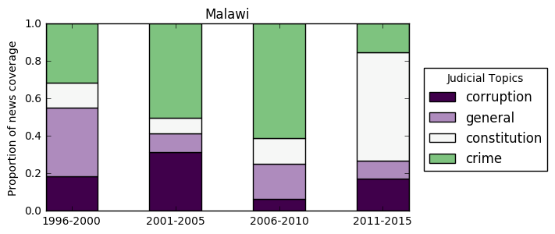

Figure 3: Kenya
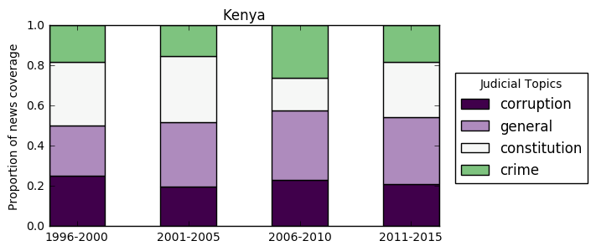

Discussion
The fact that courts have proven less subservient in Malawi than Kenya is no accident of history. These divergent outcomes reflect longstanding legacies of autocratic rule. In Malawi, the judiciary has never been a reliable agent of the executive. This distrust traces back to the early years of independence, when conflict between the English common law courts and Malawian president led to the establishment of the Traditional Courts in 1969, a system of retributive justice that operated beyond the purview of the normal judicial system. The creation of these tribunals was a direct attack on common law courts, which was in many respects a holdover institution from the colonial period. While the common law courts continued to exist, they were politically neutralized under the one-party dictatorship that governed Malawi until 1994. The Traditional Courts thus exercised jurisdiction over all criminal cases, including treason, where decisions were made by tribal chieftains answering directly to the president.

When the Traditional Courts were formally abolished in 1994 under the new democratic constitution, this required streamlining the judiciary under the common law system. Criminal jurisdiction was thus deferred back to the regular courts, which at least partially explains the refocus on criminal jurisdiction during the 1990s and early 2000s in Figure 2. The other factor driving these trends were rising crime rates (Ellet 2015).

These trends also reveal lingering legacies of autocratic practices on post-transition governance. In particular, the hostilities between the executive and judiciary which defined the one-party era to a certain extent carried over to multi-party era. In Malawi, the common law judiciary was never a perfect agent of the president, and only continued to challenge political authority when their jurisdiction was expanded after the democratic transition. Taken in historical perspective, recent efforts to stymie judicial power after controversial rulings, especially in constitutional affairs, is part of a long-standing tradition of executive-judicial interaction in Malawi.

By contrast, the Kenyan judiciary has long held a reputation for political subservience (Oseko 2011). From independence in 1963 until the general elections of 2002, the common law courts were relatively reliable agents of the government, rarely ruling against the interests of the ruling party. This meant that the common law courts exercised relatively wide jurisdiction over cases of political import. During the autocratic years, the common law courts heard a variety of election petitions, sedition cases, and treason cases, and could ultimately be relied upon to deliver verdicts that were favorable to the one-party regime.

While decades of judicial obedience have led to a stable relationship between judges and presidents, they have also weakened public trust in the judiciary and undermined confidence in the rule of law. Widely held perceptions of political bias in the courts have dis-incentivized people from using these institutions, and even encouraged forum shopping for the “right” judge. Such behaviors not only undermine the legitimacy of formal legal institutions, but are detrimental to the consolidation of democratic power (Carothers 2002). While recent efforts at judicial reform have attempted to address some of the worst excesses of judicial corruption, these efforts have not significantly improved public evaluations of judicial behavior, which have remained relatively consistent over time. It will likely take much longer for the Kenyan courts to overwrite these autocratic legacies.

Conclusion
The findings from this chapter demonstrate that jurisdiction is a dynamic and multifaceted aspect of judicial power. I illustrate these findings using a series of static and dynamic topic models on jurisdictional topics in African news media, which reveal how judicial authority is discussed and interpreted in local context. By examining the exercise of jurisdictions in different countries over time, I have shown that the scope of judicial authority can be interpreted as product of broader political factors, including conflicts over government control and the level of trust between judges and executives.

This analysis has several implications. First, focusing on jurisdiction can offer important insight into the exercise of judicial power in countries with long histories of autocratic rule. In these settings, courts were originally designed to protect arbitrary power, not democratic rule of law, usually by delimiting the scope of judicial authority. This meant that courts could be relatively independent in some cases, but completely dependent in others. These were the institutional legacies confronting most African countries during the early 1990s when governments began to liberalize, and may help explain why evaluations of judicial performance have been largely mixed ever since. Contemporary African courts have been both lauded for their efforts to hold government accountable but also criticized for deferring to political interests (Gloppen 2003; Vondoepp 2005; Ellet 2015). This inconsistency has made it difficult to discern whether courts have actually made meaningful advances or remain under the thumb of incumbent politicians (Gloppen and Kanyongolo 2005). In light of these trends, jurisdiction may offer a more nuanced indicator of autocratic holdovers than democratic metrics. These findings also suggest that whatever jurisdiction a court exercises today is not merely a reflection of contemporary politics, but also stems from deeply entrenched historical behaviors.

Second, the topic modeling approach provides a relatively efficient means of analyzing jurisdiction in cross-national context. By leveraging contemporary news media, this method is also able to discern how patterns of jurisdiction can evolve over time. While the models presented here are able to synthesize a vast quantity of textual information in a relatively condensed form, they are not a substitute for qualitative text analysis. Rather, these models are merely a tool to categorize text on a massive scale, the output of which still requires human interpretation.

Third, any news-based metric of jurisdiction is only as reliable as the news sources themselves. While the media sources analyzed in this chapter are considered largely reliable, countries with more restricted or polarized media environments may be more difficult to analyze. Jurisdictional studies would thus be greatly enhanced by turning to primary court documents, such as court transcripts or formal verdicts that are issued directly by judicial actors. The current limitations of such data have been discussed elsewhere in this chapter, but in a variety of developing countries, court records are increasingly being published online. The continued digitization of these records will ultimately create new avenues for generating jurisdictional topic models.
Appendix
To evaluate the strength of the local media in African countries, I use data from the Varieties of Democracy Project (V-Dem), focusing on indicators for press freedom. Figures 4 and 5 display the V-Dem Freedom of Expression index and Alternative Sources of Information index, respectively. The Free Expression index measures the extent to which government respects press and media freedom. The Alternative Sources index measures the extent to which the media is considered un-biased in their coverage (or lack thereof) of the opposition, government criticism, and representative of a wide array of political perspectives. The measures show that both indicators have largely converged for the countries in the sample over the period under study. This suggests that differences in media coverage are not being driven by underlying differences in media freedom.
Figure A1:
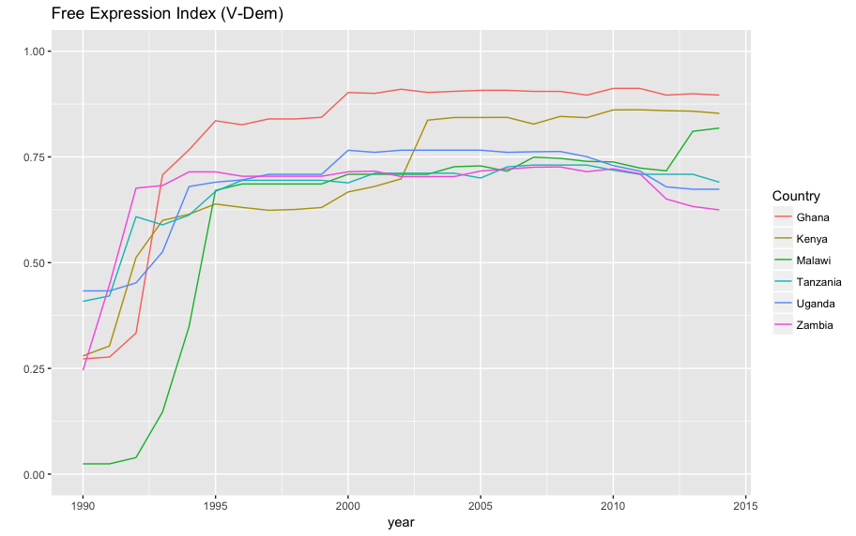

Figure A2:
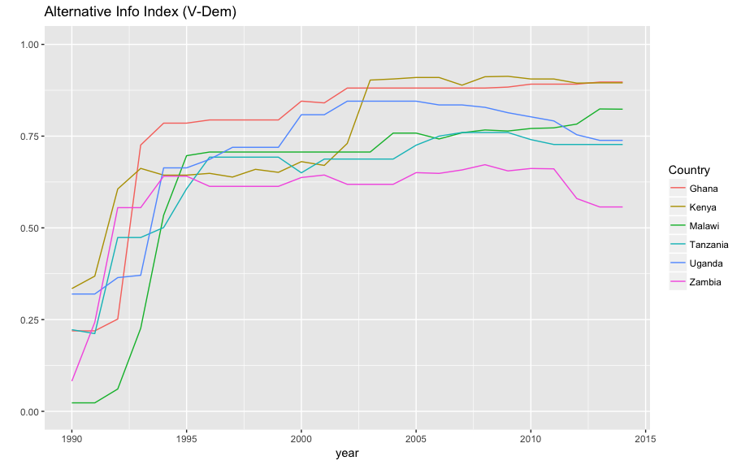
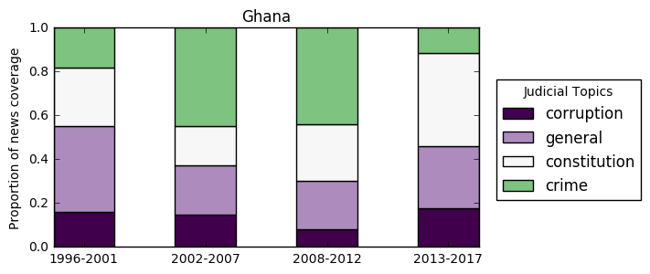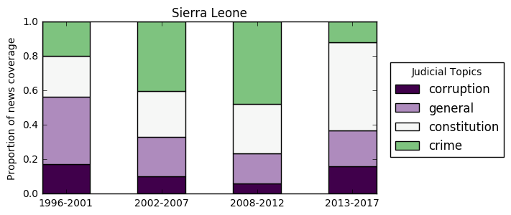
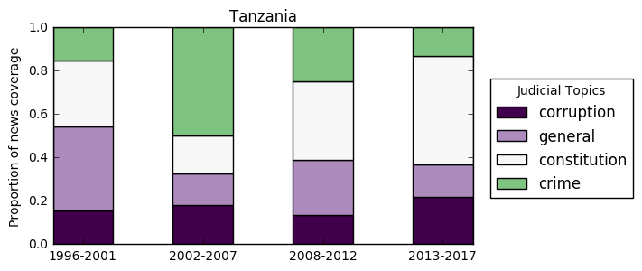
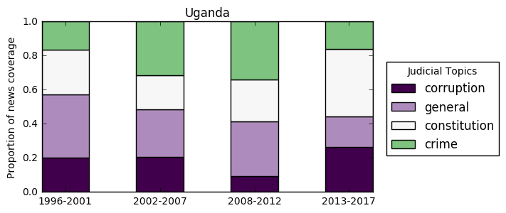
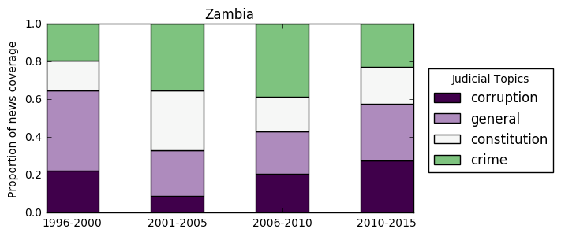

Works Cited
Albertus, M. and Menaldo, V. (2012), Dictators as Founding Fathers? The Role of Constitutions Under Autocracy. Economics and Politics, 24: 279–306. doi:10.1111/j.1468-0343.2012.00402.x
Amar, A. (1989). Marbury, Section 13, and the Original Jurisdiction of the Supreme Court. The University of Chicago Law Review, 56(2), 443-499. doi:10.2307/1599844
Amnesty International. 9 November 1990. Amnesty International Report: AFR 32/38/90. Available at: https://www.amnesty.org/download/Documents/200000/afr320381990en.pdf
Aoláin, Fionnuala Ni and Oren Gross. 2013. Guantánamo and Beyond: Exceptional Courts and Military Commissions in Comparative Perspective. Cambridge University Press.
Althaus, S., Edy, J., & Phalen, P. (2001). Using Substitutes for Full-Text News Stories in Content Analysis: Which Text Is Best? American Journal of Political Science, 45(3), 707-723. doi:10.2307/2669247.
Becker, Theodore. 1970. Comparative Judicial Politics. University Press of America.
Bermeo, N. (2016). On Democratic Backsliding. Journal of Democracy 27(1), 5-19. The Johns Hopkins University Press. Retrieved July 15, 2017, from Project MUSE database.
Blei, David. (2012). Probabilistic Topic Models. Communications of the ACM 55 (4): 77-84. doi:10.1145/2133806.2133826.
Bratton, M., & Van de Walle, N. (1992). Popular Protest and Political Reform in Africa. Comparative Politics, 24(4), 419-442. doi:10.2307/422153
Jonathan Chang, Jordan Boyd-Graber, Chong Wang, Sean Gerrish, and David M. Blei. Reading “Tea Leaves: How Humans Interpret Topic Models.” Neural Information Processing Systems, 2009.
Coppedge, Michael, John Gerring, Staffan I. Lindberg, Svend-Erik Skaaning, Jan Teorell, Joshua Krusell, Kyle L. Marquardt, Valeriya Mechkova, Daniel Pemstein, Josefine Pernes, Laura Saxer, Natalia Stepanova, Eitan Tzelgov, Yiting Wang and Steven Wilson. 2017. “V-Dem Methodology v7.1.” Varieties of Democracy (V-Dem) Project.
Cover, R. (1985). The Folktales of Justice: Tales of Jurisdiction. Capital University Law Review 14(2), 179-204.
Crabtree, Charles D and Christopher J Fariss. (2015). “Uncovering patterns among latent variables: human rights and de facto judicial independence.” Research & Politics, Vol 2, Issue 3, doi: 10.1177/2053168015605343.
Davenport, Christian and Patrick Ball. (2002). Views to a Kill: Exploring the Implications of Source Selection in the Case of Guatemalan State Terror, 1977-1995. Journal of Conflict Resolution. Vol 46, Issue 3, pp. 427 – 450. Doi: 10.1177/0022002702046003005
Ellett, Rachel. (2015). “Politics of Judicial Independence in Malawi.” Freedom House.
Entman, R. M. (2007), Framing Bias: Media in the Distribution of Power. Journal of Communication, 57: 163–173. doi:10.1111/j.1460-2466.2006.00336.x
Finkel, J. (2003). Supreme Court Decisions on Electoral Rules after Mexicos 1994 Judicial Reform: An Empowered Court. Journal of Latin American Studies, 35(4), 777-799. doi:10.1017/S0022216X03006989
Flemming, R., Wood, B., & Bohte, J. (1999). Attention to Issues in a System of Separated Powers: The Macrodynamics of American Policy Agendas. The Journal of Politics, 61(1), 76-108. Retrieved from http://www.jstor.org/stable/2647776
Franzosi, Roberto. (1987). The Press as a Source of Socio-Historical Data: Issues in the Methodology of Data Collection from Newspapers. Historical Methods: A Journal of Quantitative and Interdisciplinary History, 20:1, 5-16, DOI: 10.1080/01615440.1987.10594173
Ginsburg, Tom, and Tamir Moustafa, eds. 2008. Rule by Law: The Politics of Courts in Authoritarian Regimes. Cambridge University Press.
Gloppen, Siri. (2003). “The accountability function of the courts in Tanzania and Zambia.” Democratization 10:4, 112-136. DOI: 10.1080/13510340312331294057
Grimmer, J., & Stewart, B. (2013). Text as Data: The Promise and Pitfalls of Automatic Content Analysis Methods for Political Texts. Political Analysis, 21(3), 267-297. doi:10.1093/pan/mps028
Hart, H. (1953). The Power of Congress to Limit the Jurisdiction of Federal Courts: An Exercise in Dialectic. Harvard Law Review, 66(8), 1362-1402. doi:10.2307/1336866
Huntington, S. P. 1993. The Third Wave: Democratization in the Late Twentieth Century. University of Oklahoma Press.
Jackman, R., & Boyd, W. (1979). Mutiple Sources in the Collection of Data on Political Conflict. American Journal of Political Science, 23(2), 434-458. doi:10.2307/2111011
Jaffe, L. (1964). Primary Jurisdiction. Harvard Law Review, 77(6), 1037-1070. doi:10.2307/1339061
Kyle, B. J. and Reiter, A. G. (2013), Militarized Justice in New Democracies: Explaining the Process of Military Court Reform in Latin America. Law & Society Review, 47: 375–407. doi:10.1111/lasr.12019
Linzer, Drew A. and Jeffrey K. Staton. (2015). “A Global Measure of Judicial Independence, 1948–2012.” Journal of Law and Courts 3, no. 2 (Fall): 223-256.
Lucas, Christopher, Richard A Nielsen, Margaret E Roberts, Brandon M Stewart, Alex Storer, Dustin Tingley. (2015). Computer-assisted text analysis for comparative politics. Political Analysis 23(2): 254-277. doi:10.1093/pan/mpu019
Magaloni, Beatriz. 2008. “Credible Power-Sharing and the Longevity of Authoritarian Rule.” Comparative Political Studies, 41, Issue 4-5: 715 – 741.
Mahmud T. 1994. Jurisprudence of successful treason: coup detat & common law. Cornell Int. Law J. 27: 49–140.
McCallum, Andrew Kachites. “MALLET: A Machine Learning for Language Toolkit.” http://mallet.cs.umass.edu. 2002.
McCarthy, J., McPhail, C., & Smith, J. (1996). Images of Protest: Dimensions of Selection Bias in Media Coverage of Washington Demonstrations, 1982 and 1991. American Sociological Review, 61(3), 478-499. Retrieved from http://www.jstor.org/stable/2096360
McGowan, P., & Johnson, T. (1984). “African Military Coups dÉtat and Underdevelopment: A Quantitative Historical Analysis.” The Journal of Modern African Studies, 22(4), 633-666. doi:10.1017/S0022278X00056275
Mickey, Robert. 2015. Paths Out of Dixie: The Democratization of Authoritarian Enclaves in America’s Deep South, 1944–1972. Princeton, NJ: Princeton University Press.
Mimno, D. (2012). “Computational Historiography: Data Mining in a Century of Classics Journals.” J. Comput. Cult. Herit., 5, 3:1-3:19. doi: 10.1145/2160165.2160168
Moustafa, Tamir. (2014). “Law and Courts in Authoritarian Regimes.” Annual Review of Law and Social Science 10 (September): 281–99.
Mutua, M. (2001). Justice under Siege: The Rule of Law and Judicial Subservience in Kenya. Human Rights Quarterly 23(1), 96-118. The Johns Hopkins University Press. Retrieved August 8, 2017, from Project MUSE database.
O’Brien, K.J. and Rongbin Han. 2009. “Path to Democracy? Assessing village elections in China.” Journal of Contemporary China Vol. 18, 60.
Pierson, P. (2000), The Limits of Design: Explaining Institutional Origins and Change. Governance, 13: 475–499. doi:10.1111/0952-1895.00142
Quinn, K. M., Monroe, B. L., Colaresi, M., Crespin, M. H. and Radev, D. R. (2010), How to Analyze Political Attention with Minimal Assumptions and Costs. American Journal of Political Science, 54: 209–228. doi:10.1111/j.1540-5907.2009.00427.x
Raleigh, Clionadh, Andrew Linke, Håvard Hegre and Joakim Karlsen. 2010. Introducing ACLED-Armed Conflict Location and Event Data. Journal of Peace Research 47(5) 651-660.
Riedl, Rachel. (2014). Authoritarian Origins of Democratic Party Systems in Africa. Cambridge University Press.
Ríos-Figueroa, Julio and Jeffrey K. Staton. 2014. An Evaluation of Cross-National Measures of Judicial Independence. J Law Econ Organ 30 (1): 104-137. doi: 10.1093/jleo/ews029
Schedler, A. (2010). Authoritarianisms Last Line of Defense. Journal of Democracy 21(1), 69-80. The Johns Hopkins University Press. Retrieved July 18, 2017, from Project MUSE database.
Schofield, Alexandra & David Mimno. (2016). Comparing Apples to Apple: The Effects of Stemmers on Topic Models. Transactions of the Association for Computational Linguistics 4: 287-300.
Tate, C., & Haynie, S. (1993). Authoritarianism and the Functions of Courts: A Time Series Analysis of the Philippine Supreme Court, 1961-1987. Law & Society Review, 27(4), 707-740. doi:10.2307/3053951.
Toharia, J. (1975). Judicial Independence in an Authoritarian Regime: The Case of Contemporary Spain. Law & Society Review, 9(3), 475-496. doi:10.2307/3053168
Vondoepp, Peter. (2005). “The Problem of Judicial Control in Africa's Neopatrimonial Democracies: Malawi and Zambia.” Political Science Quarterly, Vol. 120, No. 2: pp. 275-301. http://www.jstor.org/stable/20202519.
Walker, J. (1977). Setting the Agenda in the U.S. Senate: A Theory of Problem Selection. British Journal of Political Science, 7(4), 423-445. doi:10.1017/S0007123400001101
Weinstein, Jeremy. (2006). Inside Rebellion: The Politics of Insurgent Violence. Cambridge University Press.
Woolley, J. (2000). Using Media-Based Data in Studies of Politics. American Journal of Political Science, 44(1), 156-173. doi:10.2307/2669301

Weinstein (2006); Bratton and Van de Walle (1992); McGowan (1984).
See ACLED, Polity IV, Varieties of Democracy.
De jure concepts deal with formal rules designed to insulate judges from undue pressure (Rios-Figueroa and Staton 2014). Examples include life-long tenure (LaPorta et al 2003), multilateral appointment procedures (Melton and Ginsburg 2014), and the creation of external supervisory bodies (Garoupa and Ginsburg 2008).
De facto concepts deal with the actual decisions delivered by judges, in particular, whether they reflect the autonomous preferences of judges (Becker 1970). An extension of this idea is that judicial decisions are enforced in practice even when political actors would rather not comply (Rios-Figueroa and Staton 2014).
Measure of CIM by Clague et al. CIM (1999); CIRI = Cingranelli & Richards (2008) measure of Judicial Independence; F&V-F and F&V-J = Feld and Voigts (2003) measure of De Jure and De Facto Judicial Independence; GCR measure of “judicial independence; Wittold Heniszs (2000) measure of judicial independence; H&C (2004) measure of judicial independence; KEITH = Keiths (2002) measure of judicial independence; La Porta et al (2004) measure “Judicial Checks” and Balances”; T&K = Tate & Keith (2007) measure of judicial independence; and, XCONST = Polity measure on “Constraints on the Executive” (Gurr 1990).
See Varities of Deocracy, Polity IV, World Bank Governance Indicators.
For example, see Reuters, June 8, 2017, “Zambian opposition leaders treason case headed for trial,” accessed at http://www.reuters.com/article/us-zambia-politics-idUSKBN18Z13S; Fergus Jensen and Kanupriya Kapoor, March 30, 2017, “Indonesia arrests Muslim leader for treason ahead of rally,” accessed at http://www.reuters.com/article/us-indonesia-politics-protests-idUSKBN1720GT.
In Kenya, for instance, the government developed new strategies of political repression after human rights monitors like Amnesty International condemned them for detaining political prisoners without trial in the 1980s and 1990s. The Kenyan government instead began charging opposition members with violent crimes against the state, disincentivizing human rights groups from intervening on behalf of allegedly violent criminals (Amnesty 1990).
Amnesty (2002).
Mickey (2015).
O’Brien and Han (2009).
U.S. Supreme Court decision in Ex parte McCardle, 7 Wall. 506, 514 (U.S. 1868). Hart, H. (1953). The Power of Congress to Limit the Jurisdiction of Federal Courts: An Exercise in Dialectic. Harvard Law Review, 66(8), 1362-1402. doi:10.2307/1336866
See Linzer and Staton (2015) for a comprehensive overview of existing measurement practices.
For instance, the Varieties of Democracy dataset includes a categorical indicator for whether a given country recognizes “Specialized Courts,” some of which may fall outsider of regular court jurisdiction. Similarly, the World Justice Project Rule-of-Law index includes an “Informal Justice” measure that accounts for whether customary systems of justice are recognized. However, beyond acknowledging the existence of these auxiliary institutions, these measures do not specifically evaluate whether this jurisdiction is actually exercised, or how it affects the authority of the regular court. See https://worldjusticeproject.org/our-work/wjp-rule-law-index/wjp-rule-law-index-2016/factors-rule-law/informal-justice-factor-9.
These terms were selected for their specificity. Other judicial terms, such as judge, have multiple substantive meanings and thus returned many false positive search results.
1996 is the earliest year of record on the site.
Stop words are frequently occuring words such as “a”, “and”, “are”, “the”, and “it”.
More specifically, topics are generated by taking each word within a document and calculating the probability that this word is associated with a pre-specified number of latent topics (Blei 2012).
The IDF is the logarithm of the number of documents divided by the number of documents containing the term. This reduces the TF weight by a factor that grows with the number of documents. Higher weights are given to terms that occur frequently within a small number of documents, lower weights are given to terms that occur rarely or frequently across many documents. See https://nlp.stanford.edu/IR-book/html/htmledition/tf-idf-weighting-1.html.
Probabilistic models tend to over-generalize and produce redundant results (O’Callaghan et al. 2015).
In other words, models are repeatedly run with varying numbers of topics and ultimately evaluated by whether the model produces substantive output or coherent topics.
See http://www.nyasatimes.com/malawi-treason-trial-start-april-4-mutharika-and-others-to-make-plea/.
Maya Gainer, July 9, 2016, “How Kenya Cleaned Up Its Courts,” Accessed at http://foreignpolicy.com/2016/07/09/how-kenya-cleaned-up-its-courts/
As opposition leader Raila Odinga remarked at the time, “we will not go to the courts controlled by President Kibaki.” In Stephen Ndegwa, “Kenya: Raila Calls for Vote Recount,” accessed at http://allafrica.com/stories/200712300020.html.
“Kenya: Prosecute Perpetrators of Post-Election Violence,” accessed at https://www.hrw.org/news/2011/12/09/kenya-prosecute-perpetrators-post-election-violence.
Accessed at http://foreignpolicy.com/2016/07/09/how-kenya-cleaned-up-its-courts/.
Sheila Rule, August 4, 1988, “Kenya Restricts Independence of Judges,” http://www.nytimes.com/1988/08/04/world/kenya-restricts-independence-of-judges.html
Afrobarometer Round 6 survey, 2015.
Cathy Majtenyi, May 9 2012, “Slowly but Surely, Kenya Cleans Up Judiciary,” https://www.voanews.com/a/slowly_but_surely_kenya_cleans_up_judiciary/416868.html

